**ASSIGNMENT 1 FRONT SHEET**

|  |  |  |  |
| --- | --- | --- | --- |
| **Qualification** | **BTEC Level 5 HND Diploma in Computing** | | |
| **Unit number and title** | Unit 9: Software Development Life Cycle | | |
| **Submission date** | 08/01/2021 | **Date Received 1st submission** |  |
| **Re-submission Date** |  | **Date Received 2nd submission** |  |
| **Student Name** | Phan Minh Tri | **Student ID** | GCC18015 |
| **Class** | GCC0701 | **Assessor name** | Nguyen Thai Nghe |
| **Student declaration**  I certify that the assignment submission is entirely my own work and I fully understand the consequences of plagiarism. I understand that making a false declaration is a form of malpractice. | | | |
|  |  | **Student’s signature** | phantri |

**Grading grid**

|  |  |  |  |  |  |  |  |
| --- | --- | --- | --- | --- | --- | --- | --- |
| P1 | P2 | P3 | P4 | M1 | M2 | D1 | D2 |
|  |  |  |  |  |  |  |  |

|  |  |  |
| --- | --- | --- |
| **❒ Summative Feedback: ❒ Resubmission Feedback:** | | |
| **Grade:** | **Assessor Signature:** | **Date:** |
| **Internal Verifier’s Comments:** | | |
| **Signature & Date:** | | |

**ASSIGNMENT 1 BRIEF**

|  |  |  |  |
| --- | --- | --- | --- |
| **Qualification** | **BTEC Level 5 HND Diploma in Computing** | | |
| **Unit number** | Unit 9: Software Development Life Cycle | | |
| **Assignment title** | Planning a software development lifecycle | | |
| **Academic Year** | 2019 – 2020 | | |
| **Unit Tutor** | LE Minh Duc | | |
| **Issue date** |  | **Submission date** |  |
| **Name and date** |  | | |

|  |  |
| --- | --- |
| **Submission Format:** | |
| *Format:* | The submission is in the form of 1 document.  You **must** use the *Times font* with *12pt size*, turn on *page numbering*; set *line spacing to 1.3* and *margins* to be as follows: left = 1.25cm, right = 1cm, top = 1cm, bottom = 1cm. Citation and references must follow the Harvard referencing style.  **Word limit: 2000 words** |
| *Submission:* | You **must** submit the assignment **by the due date** and follow the submission method specified by the Tutor. The submission form is **soft copy**, which is to be uploaded to the following URL: [http://cms.greenwich.edu.vn](http://cms.greenwich.edu.vn/). |
| *Note:* | Your assignment *must* be your own work, and not copied by or from another student or from other sources, such as book etc. If you use ideas, quotes or data (such as diagrams) from books, journals or other sources, you must reference the sources, using the Harvard style. Make sure that you know how to reference properly and that you understand the plagiarism guidelines. **Plagiarism is a very serious offence**, which will result in a failing grade. |
| **Unit Learning Outcomes:** | |
| **LO1** Describe different software development lifecycles.  **LO2** Explain the importance of a feasibility study**.** | |
| **Assignment Brief and Guidance:** | |
| **System Scenario**  Tune Source is a company headquartered in southern California. Tune Source is the brainchild of three entrepreneurs with ties to the music industry: John Margolis, Megan Taylor, and Phil Cooper. Originally, John and Phil partnered to open a number of brick and mortar stores in southern California specialising in hard-to-find and classic jazz, rock, country, and folk recordings. Megan soon was invited to join the partnership because of her contacts and knowledge of classical music. Tune Source quickly became known as the place to go to find rare audio recordings. Annual sales last year were $40 million with annual growth at about 3%–5% per year. Tune Source currently has a website that enables customers to search for and purchase CDs. This site was initially developed by an Internet consulting firm and is hosted by a prominent local Internet Service Provider (ISP) in Los Angeles. The IT department at Tune Source has become experienced with Internet technology as it has worked with the ISP to maintain the site.  **System Request**  **Project Sponsor**: Carly Edwards, Assistant Vice President, Marketing  **Business Need**: This project has been initiated to increase sales by creating the capability of selling digital music downloads to customers through kiosks in our stores, and over the Internet using our website.  **Business Requirements**: Using the Web or in-store kiosks, customers will be able to search for and purchase digital music downloads. The specific functionality that the system should have includes the following:   * Search for music in our digital music archive. * Listen to music samples. * Purchase individual downloads at a fixed fee per download. * Establish a customer subscription account permitting unlimited downloads for a monthly fee. * Purchase music download gift cards.   **Business Value**: We expect that Tune Source will increase sales by enabling existing customers to purchase specific digital music tracks and by reaching new customers who are interested in our unique archive of rare and hard-to-find music. We expect to gain a new revenue stream from customer subscriptions to our download services. We expect some increase in cross-selling, as customers who have downloaded a track or two of a CD decide to purchase the entire CD in a store or through our website. We also expect a new revenue stream from the sale of music download gift cards.  Conservative estimates of tangible value to the company include the following:   * $757,500 in sales from individual music downloads * $950,000 in sales from customer subscriptions * $205,000 in additional in-store or website CD sales * $153,000 in sales from music download gift cards   Special Issues or Constraints:   * The marketing department views this as a strategic system. The ability to offer digital music downloads is critical in order to remain competitive in our market niche. Our music archive of rare and hard-to-find music is an asset that is currently underutilised. * Many of our current loyal customers have been requesting this capability, and we need to provide this service or face the loss of these customers’ business. * Because customers have a number of music download options available to them elsewhere we need to bring this system to the market as soon as possible.   **Tasks**  Complete the following tasks:  **Task 1 – SDLC model**  You are a project manager of a company named ABC. Your company has been hired by Tune Source to carry out a project that helps them develop a software for the requirements specified in the system request. As the first step, you need to:   1. (P1) Describe the following SDLC models: waterfall, v-model, prototyping, agile and spiral. Choose one that you think suitable for the project and explain why.    * 350 - 500 words for each model    * Explanation: 400 – 600 words   (M1) Discuss the suitability of each of the SDLC models for the project. For each model, specify whether it is most, moderately or least suitable.   * + Discussion and arguments: 800 - 1000 words   (D1) Discuss the merits of applying the waterfall model to a large software development project.   * + Discussion: 800 – 1200 words  1. (P2) Identify some risks and discuss an approach to manage them.    * You will have the present what is Risk Management process with clear illustrations and explanations    * Then you will create a Risk Management Plan to manage risks of TuneSource project   **Task 2 – Feasibility study**   1. (P3) Discuss the purpose of conducting a feasibility study for the project.    * Discussion: 400 – 1600 words 2. (P4) Discuss how the three feasibility criteria (technical, economic, organisational) are applied to the project. Discuss whether the project is feasible.   Discuss alternative technical solutions using the alternative matrix.  Discussion: 1200 – 1500 words   1. (M2) Explain the components of a feasibility report.    * Discussion economic feasibility study: 350 – 500 words    * Discussion organizational feasibility study: 350 – 500 words 2. (D2) Assess the impact of each feasibility criterion on a software investigation.    * Discussion and represent as feasibility alternatives matrix for: 700 – 900 words | |

|  |  |  |
| --- | --- | --- |
| Learning Outcomes and Assessment Criteria | | |
| Pass | Merit | Distinction |
| **LO1 Describe different software development lifecycles** | | **D1** Assess the merits of applying the Waterfall lifecycle model to a large software development project. |
| **P1** Describe two iterative and two sequential software lifecycle models.  **P2** Explain how risk is managed in the Spiral lifecycle model. | **M1** Describe, with an example, why a particular lifecycle model is selected for a development environment. |
| **LO2 Explain the importance of a feasibility study** | | **D2** Assess the impact of different feasibility criteria on a software investigation. |
| **P3** Explain the purpose of a feasibility report.  **P4** Describe how technical solutions can be compared. | **M2** Discuss the components of a feasibility report. |

**P1 Describe two iterative and two sequential software lifecycle models.**

**Iterative:** Spiral, Agile

Describe, Advantages, Disadvantages

**Sequential:** Waterfall, V-model

Describe, Advantages, Disadvantages

Choose one that you think suitable for the project and explain why

**P2 Explain how risk is managed in the Spiral lifecycle model.**

* **Risk Handling in Spiral Model**
* **Risk handling in your project**
  + **Overtime ?**
  + **Overcost?**
  + **Human change?**
  + **Legal change?**
  + **..**

**P3 Explain the purpose of a feasibility report**

* What is Feasibility Study? (its purpose)
* Types of Feasibility Study (technical, economic, organisational,..)
* Importance of Feasibility Study

**P4 Describe how technical solutions can be compared.**

* Discuss how the three feasibility criteria (technical, economic, organisational) are applied to the project.
  + Technical: new technologies? Programming language, Database,.. (slides 10-11)
  + Economic: Estimate costs, Analyzing Costs vs. Benefits (calculate Present value, ROI, Payback value – slides 17-22)
  + Organisational: Human and social issues: Social acceptability? Legal aspects (copyright, download,..) and government regulations (prohibited musics?,..),...
* Discuss whether the project is feasible: After Analyzing Costs vs. Benefits
* Discuss alternative technical solutions using the alternative matrix (slides 32-34)

Contents

**P1** Describe two iterative and two sequential software lifecycle models. 10

**P2** Explain how risk is managed in the Spiral lifecycle model. 15

**P3** Explain the purpose of a feasibility report. 17

**P4** Describe how technical solutions can be compared. 18

References 20

# **P1** Describe two iterative and two sequential software lifecycle models.

* SDLC MODELS

1. **Waterfall SDLC Model**

Waterfall – is a waterfall SDLC model in which the creation process appears like a river, going step by step through the stages of analysis, projection, realization, testing, execution, and assistance. This SDLC model fully encompasses the incremental execution of each level. This method is strictly documented and predefined with the functionality required for each step of this life-cycle software development model. (existek.com, n.d.)

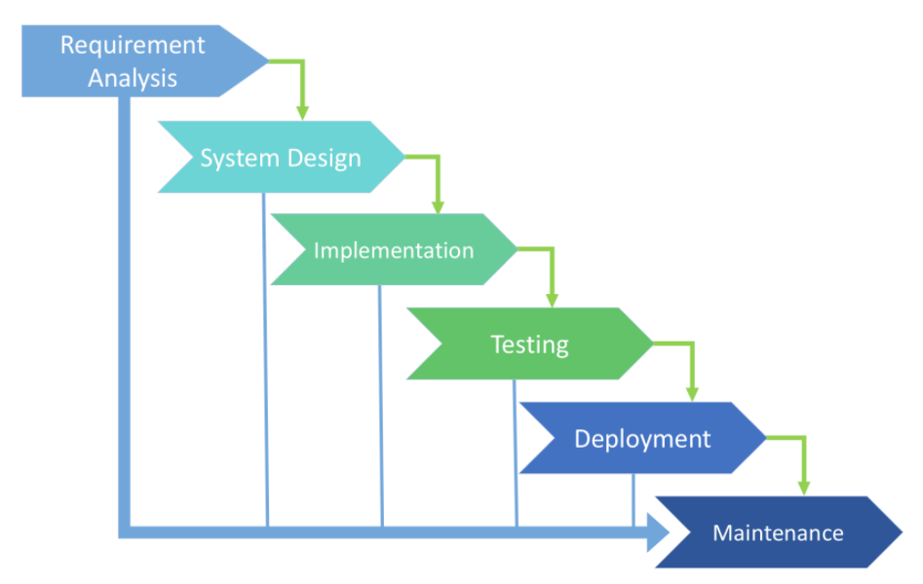

Figure 1: Waterfall SDLC Model

* ADVANTAGES
* Simple to use and understand.
* Management simplicity due to its rigidity: each step has a given outcome and a summary of the procedure.
* Development stages go one by one.
* Great for small to medium-sized projects where criteria are transparent and not equivocal.
* Simple to identify and prioritize tasks.
* Fast to identify crucial points in the growth cycle
* DISADVANTAGES
* High risks and uncertainty
* Progress of the stage is difficult to calculate as it is still under construction.
* Integration takes place at the very end of the process, which does not provide the possibility to define the issue in advance.
* Inappropriate for long-term projects.
* The program is only ready when the final stage is finished.
* Not the best alternative for dynamic, object-oriented projects.
* Use cases for the Waterfall SDLC model:
* Requirements shall be specifically recorded.
* The definition of product is stable.
* The technology stack is predefined and does not render it complex.
* No misunderstanding of specifications.
* The project is a short one.

1. **Iterative SDLC Model**

The Iterative SDLC model does not need a complete list of specifications before the project begins. The production phase can begin with the specifications of the functional component, which may be extended later on. The method is repetitive, allowing us to create new iterations of the commodity for each cycle. Each iteration (which lasts from two to six weeks) entails the creation of a new device component, which is then applied to the functional component created earlier. In terms of mathematical language, the iterative model is the application of the sequential approximation process to the incremental proximity of the intended final product form. (coursehero.com, n.d.)

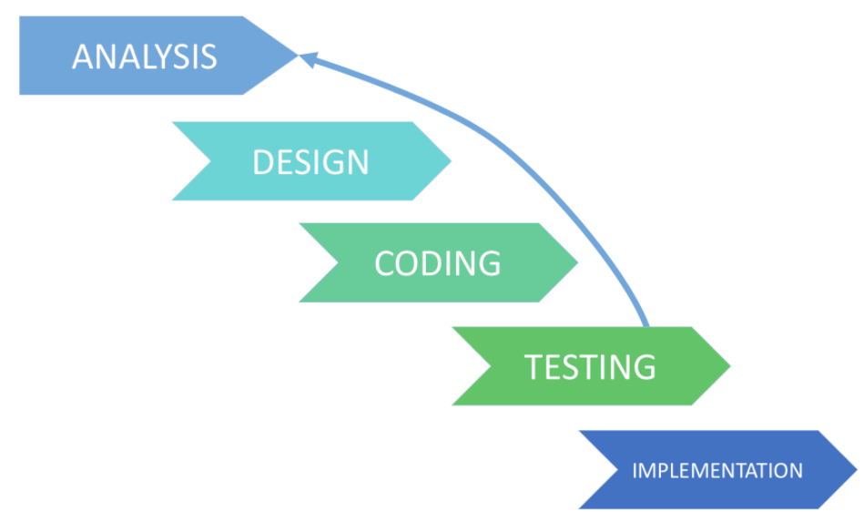

Figure 2: Iterative SDLC Model

* ADVANTAGES
* The progress is easily measurable
* Any functions can be easily established at the beginning of the life cycle of growth.
* Problems and risks identified in a single iteration can be eliminated in the next sprints.
* Harm management is simpler when high-risk activities are performed first.
* Concurrent development can be extended
* DISADVANTAGES
* Constant management is required
* The process is difficult to manage
* Risk identification requires the participation of highly trained experts
* Iterative model requires more resources than the waterfall model
* Use cases for the Iteration model:
* The specifications for the finished product are exclusively predefined.
* Applied to large programs.
* The key role is predefined, but the information will progress over time.

1. **Spiral SDLC Model**

Spiral Model – is an SDLC model that combines architecture and stage prototyping. It is a combination of the Iterative and Waterfall SDLC models with a significant emphasis on risk analysis. The key problem of the spiral model is the idea of the correct moment to take a turn into the next point. Preliminary timeframes are proposed as a solution to this problem. The change to the next stage is done according to the schedule, even though the work on the previous stage has not yet been done. The plan is applied on the basis of comparative evidence received during the previous projects and the expertise of the personal developer. (existek.com, n.d.)

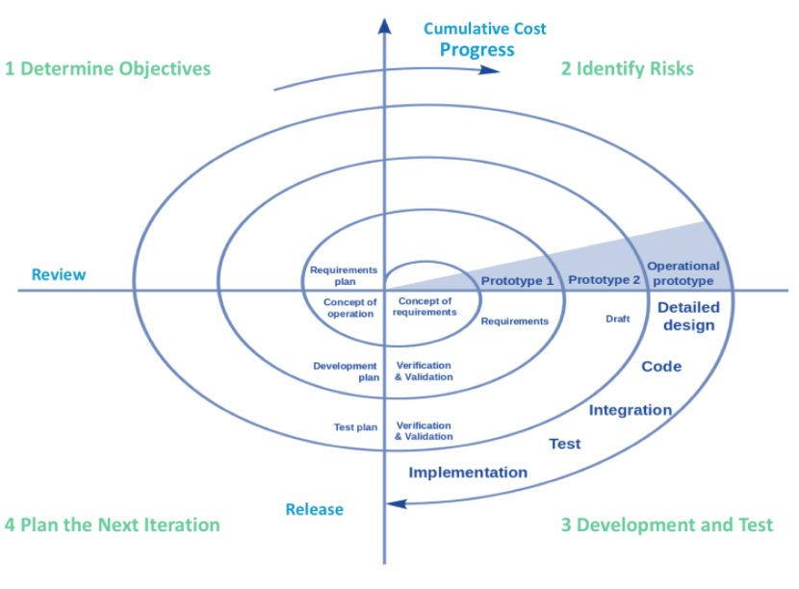

Figure 3: Spiral SDLC Model

* ADVANTAGES
* The lifecycle is split into small sections and, if the risk concentration is greater, the process should be done early to resolve the therapies.
* Scalability encourages improvements to be made and additional features to be introduced even at relatively late stages.
* The earlier working version is done-soon users will point out the shortcomings
* DISADVANTAGES
* Risk management requires the participation of highly experienced practitioners.
* Can be quite expensive
* Can be ineffective for the small projects
* Use cases for the Spiral model
* The customer is not sure of the requirements.
* Major changes are expected during the development cycle
* Mid-or high-risk projects where it is important to avoid such risks
* The new product is expected to be released in a few stages to have enough feedback from customers

1. **V-shaped SDLC Model**

The V-shaped SDLC model is an extension of the classic waterfall model and is based on the associated test stage for each stage of development. This is a very strict model, and the next stage is only started after the previous stage. It is also called the "Validation and Verification" model. Each stage has the current process control to ensure that the conversion to the next stage is possible. (coursehero.com, n.d.)

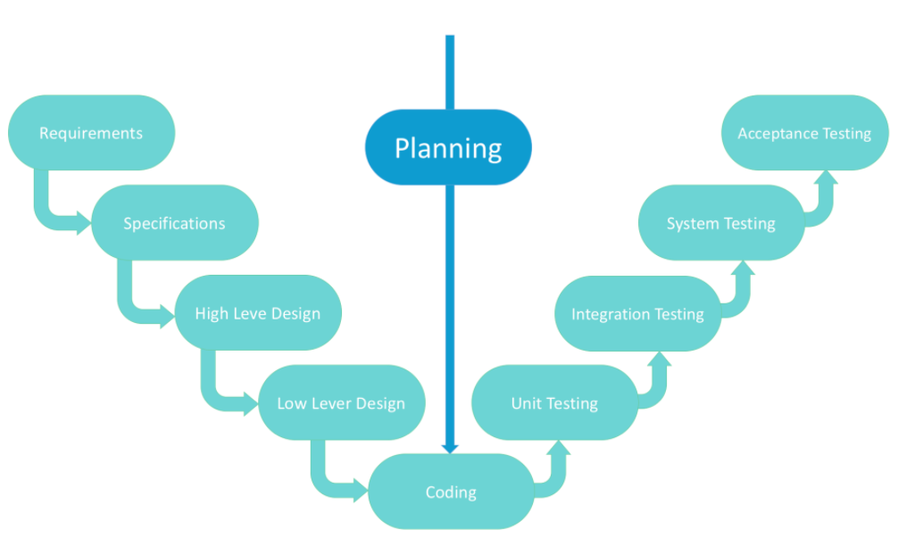

Figure 4: V-shaped SDLC Model

* ADVANTEGES
* Perfect for small projects in which specifications are static and simple.
* Checking and verification shall take place at an early stage.
* Each stage of the V-shaped model has strict effects, making it simple to monitor.
* DISADVANTAGES
* Absence of versatility
* The poor option of small tasks
* Relatively high threats
* Use cases for the V-shaped model:
* For projects in which reliable product testing is needed
* For small and medium-sized projects where specifications are narrowly predefined
* The needed certification engineers, in particular the testers, are within easy reach.

1. **Agile SDLC Model**

In the agile approach with a production iteration, the client is able to see the outcome and understand whether or not he is happy with it. This is one of the benefits of the agile life-cycle software development style. One of its drawbacks is that it is impossible to quantify resources and construction costs due to the lack of established criteria. Extreme programming is one of the functional applications of the agile paradigm. Such a model is focused on fast weekly sessions – sprints that are part of the Scrum method. (existek.com, n.d.)

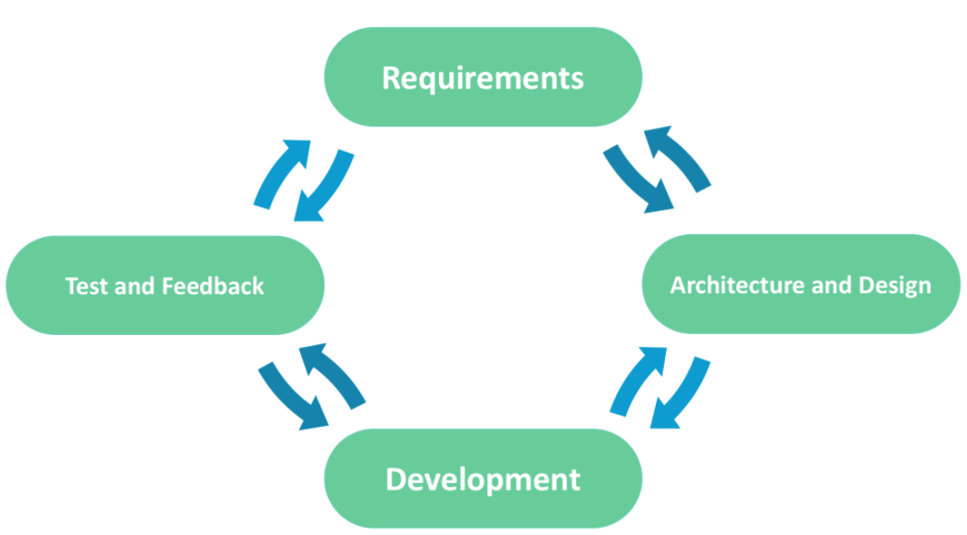

Figure 5: Agile SDLC Model

* ADVANTEGES
* Functional criteria corrections are introduced in the production phase to ensure competition
* The project is split into quick and transparent iterations.
* Quick introduction of the first edition of the software
* DISADVANTAGES
* Difficulties in calculating the ultimate expense attributable to permanent adjustments
* The staff should be extremely competent and customer-oriented.
* New specifications could be in tension with the current architecture
* Use cases for the Agile model:
* The desires of consumers to alter dynamically
* Less price for the improvement made attributable to the multiple iterations
* Unlike the Waterfall model, only initial preparation is needed to start the project.
* **I chose the Iterative SDLC Model for this project because**: In the iterative model, we can only construct a high-level implementation architecture until we finally start designing the product and determining the design solution for the whole product. Later on, we will plan and create a skeleton version of it, and then construct a design based on what was designed.

We construct and refine the product step by step in the iterative model. We may then monitor the defect in the early stages. This stops the flow from flowing down.

We will get accurate feedback from the customer in the iterative model. When showing the product drawings and blueprints to consumers for their reviews, we are basically asking them to visualize how the product would work.

In the iterative model, less time is spent on reporting and more time is spent on architecture.

# **P2** Explain how risk is managed in the Spiral lifecycle model.

* Risk is managed in the Spiral lifecycle model
* Since risk monitoring requires additional resources, this model can be pretty costly to use. Each spiral requires specific expertise, which makes the management process more complex. That’s why this SDLC model is not suitable for small projects
* A large number of intermediate stages. As a result, a vast amount of documentation
* Time management may be difficult. Usually, the end date of a project is not known in the first stages
* Developing software is fraught with uncertainty
* Uncertainty implies risk
* This needs to be quantified:
* Risk Exposure = Probability x Loss
* Can be used to choose between alternatives:
* Select the one where the expected loss is
* Risk Handling in Spiral Model

The danger is any adverse circumstance that may hinder the successful execution of a software project. The most critical aspect of the spiral model is the management of these unforeseen threats after the launch of the project.

Such danger resolution is made simpler by creating a prototype. The spiral model promotes risk assessment by having the scope to create a prototype at any level of software development.

The prototyping paradigm still promotes risk control, but risks must be thoroughly defined prior to the start of the project creation work. But real-world project risk can arise after construction work begins, in which case we cannot use the Prototyping Model.

In each step of the Spiral Model, the properties of the product are dated and evaluated, and the threats at that time are defined and addressed by prototyping. This model is also much more stable than other SDLC models. (geeksforgeeks.org, n.d.)

* Risk handling in ours project

1. Create a risk management plan.

The risk management plan should define project methodology for identifying and prioritizing risk, project risk tolerance. Developing such a plan takes time and effort, but investing in the planning phase often pays off by creating a roadmap that will guide our team throughout the execution phase of the project.

1. Keep the risk register up to date on the project

The risk register, which can either be combined with our risk management plan or a separate document, is a list of all possible risk events that have the potential to impact the project. Having this document will help us stay on top of potential issues, but it is important the project keep current so that we always have an accurate snapshot to refer to.

1. Gantt chart for Risk Management Plan

Using the Gantt map to establish comprehensive risk control strategies to avoid risk from being a concern. Schedule, delegate, and track the activities of the project with maximum visibility. Crew participants may also apply comments and files to their delegated assignments, ensuring that all contact takes place at the project level in real-time.

# **P3** Explain the purpose of a feasibility report.

* What Is a Feasibility Study?

A feasibility study is an investigation that takes into account all pertinent aspects of the project—including fiscal, technological, legal, and scheduling considerations—to assess the probability of successful completion of the project. Project managers use feasibility analyses to determine the pros and disadvantages of conducting a project before spending a lot of time and resources on it. (simplilearn.com, n.d.)

* Types of Feasibility Study

A feasibility review measures the potential for profitability of the project; thus, assumed objectivity is a crucial factor in the reliability of the report for potential borrowers and lending institutions. There are five types of feasibility studies—separate fields that the feasibility study explores, as listed below.

* Technical Feasibility
* The appraisal depends on the technological tools available to the organization. It allows organizations to assess whether the technological capabilities fulfill the potential and whether the technical staff is capable of turning concepts into functioning processes. Technical viability also includes assessing the hardware, applications, and other technical specifications of the proposed device.
* Economic Feasibility
* This evaluation usually includes a cost/benefit review of the initiative, allowing organizations to evaluate the feasibility, cost, and advantages of the project prior to the distribution of financial capital. It also acts as an independent project evaluation which strengthens the reputation of the project—helping decision-makers to find potential economic gains for the company.
* Legal Feasibility
* This review examines whether some aspect of the planned project is in conflict with legal standards such as zoning regulations, data privacy legislation, or social media legislation. Let's presume the company plans to build a new office building in a certain area. A feasibility study could show that the optimal position of the company is not for that form of enterprise. The organization has only saved a tremendous amount of time and money by learning that their proposal was not viable right from the outset.
* Operating viability
* This evaluation includes conducting an analysis to evaluate and decide whether—and how well—the needs of the company will be fulfilled by finishing the project. Operational feasibility analyses also analyze how the project proposal meets the specifications defined in the design review process of device creation.
* Scheduling Feasibility
* This evaluation is the most critical for the progress of the project; after all, the project would fail if it is not finished on schedule. In scheduling the feasibility, the company calculates how long the proposal will take to finish.
* The Importance of Feasibility Studies

Feasibility studies are critical for business growth. They will make it easier for a company to address where and how it can work. They may also recognize possible hurdles that can obstruct their activities and understand the number of funds required to keep the company up and running. Feasibility studies are targeted at communication tactics that may help to reassure customers or banks that investing in a specific project or company is a good decision. (simplilearn.com, n.d.)

# **P4** Describe how technical solutions can be compared.

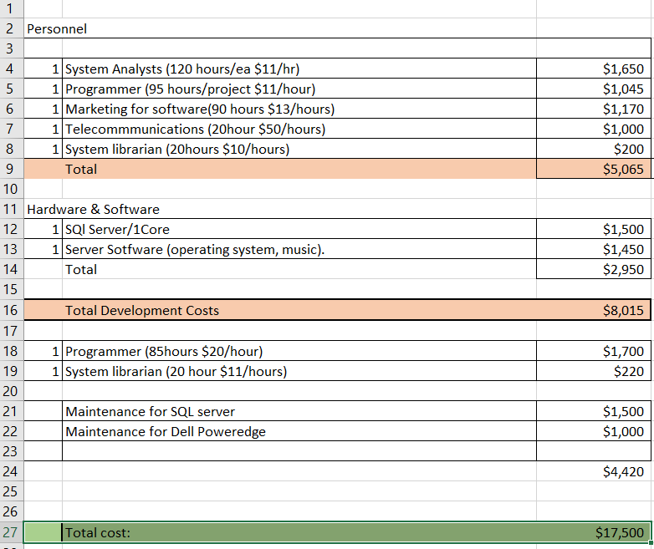

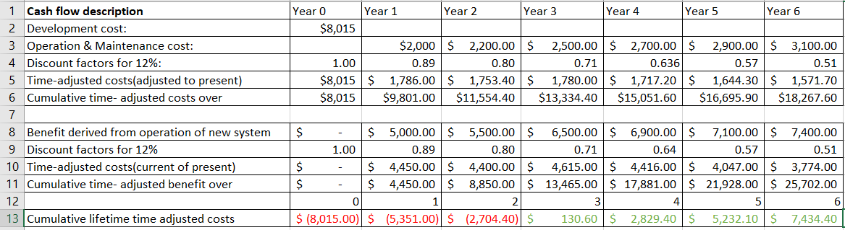Figure 6: Cost for small Client-Server project

Figure 7: Cost for small Client-Server project

* ROI = (25702 - 18268) / 18268 ≈ 40,59%
* 2704 / (130 + 2704) = 0.95
* Therefore, the payback period is approx 3.9 years

# References

coursehero.com, n.d. [Online]   
Available at: https://www.coursehero.com/  
[Accessed 7 1 2021].

existek.com, n.d. [Online]   
Available at: https://existek.com/blog/sdlc-models/  
[Accessed 7 1 2021].

geeksforgeeks.org, n.d. [Online]   
Available at: https://www.geeksforgeeks.org/software-engineering-spiral-model/#:~:text=Risk%20Handling%20in%20Spiral%20Model&text=The%20spiral%20model%20supports%20coping,development%20work%20of%20the%20project.  
[Accessed 7 1 2021].

simplilearn.com, n.d. [Online]   
Available at: https://www.simplilearn.com/feasibility-study-article  
[Accessed 7 1 2021].